Routing algorithm

* In order to transfer the packets from source to the destination, the network layer must determine the best route through which packets can be transmitted.
* Whether the network layer provides datagram service or virtual circuit service, the main job of the network layer is to provide the best route. The routing protocol provides this job.
* The routing protocol is a routing algorithm that provides the best path from the source to the destination. The best path is the path that has the "least-cost path" from source to the destination.
* Routing is the process of forwarding the packets from source to the destination but the best route to send the packets is determined by the routing algorithm.

Classification of a Routing algorithm

The Routing algorithm is divided into two categories:

* Adaptive Routing algorithm
* Non-adaptive Routing algorithm

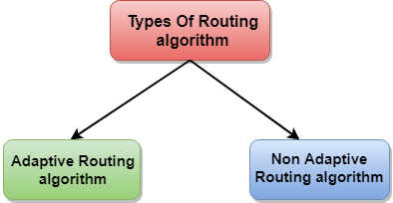

Adaptive Routing algorithm

* An adaptive routing algorithm is also known as dynamic routing algorithm.
* This algorithm makes the routing decisions based on the topology and network traffic.
* The main parameters related to this algorithm are hop count, distance and estimated transit time.

**An adaptive routing algorithm can be classified into three parts:**

* **Centralized algorithm:** It is also known as global routing algorithm as it computes the least-cost path between source and destination by using complete and global knowledge about the network. This algorithm takes the connectivity between the nodes and link cost as input, and this information is obtained before actually performing any calculation. **Link state algorithm** is referred to as a centralized algorithm since it is aware of the cost of each link in the network.
* **Isolation algorithm:** It is an algorithm that obtains the routing information by using local information rather than gathering information from other nodes.
* **Distributed algorithm:** It is also known as decentralized algorithm as it computes the least-cost path between source and destination in an iterative and distributed manner. In the decentralized algorithm, no node has the knowledge about the cost of all the network links. In the beginning, a node contains the information only about its own directly attached links and through an iterative process of calculation computes the least-cost path to the destination. A Distance vector algorithm is a decentralized algorithm as it never knows the complete path from source to the destination, instead it knows the direction through which the packet is to be forwarded along with the least cost path.

Non-Adaptive Routing algorithm

* Non Adaptive routing algorithm is also known as a static routing algorithm.
* When booting up the network, the routing information stores to the routers.
* Non Adaptive routing algorithms do not take the routing decision based on the network topology or network traffic.

**The Non-Adaptive Routing algorithm is of two types:**

**Flooding:** In case of flooding, every incoming packet is sent to all the outgoing links except the one from it has been reached. The disadvantage of flooding is that node may contain several copies of a particular packet.

**Random walks:** In case of random walks, a packet sent by the node to one of its neighbors randomly. An advantage of using random walks is that it uses the alternative routes very efficiently.

